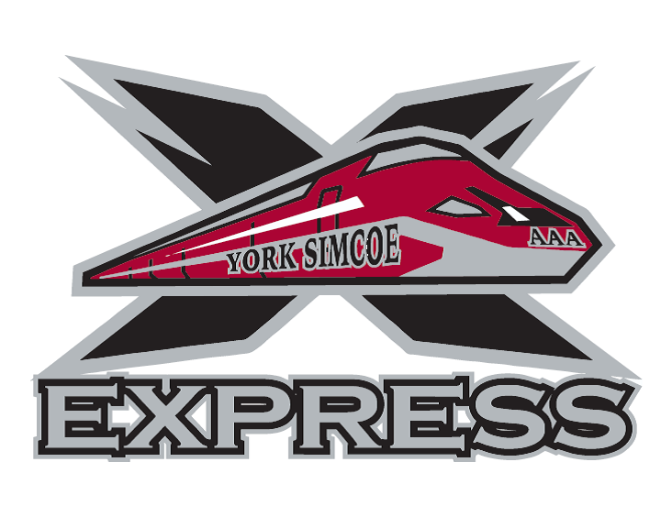

YORK SIMCOE EXPRESS
2023 ANNUAL GENERAL MEETING

NOTICE of MEETING

The 2023 Annual General Meeting of the YORK SIMCOE EXPRESS AAA Hockey Club will be held on Monday May 15th at Ray Twinney Recreation Centre in Lounge #1 beginning at 7:00 PM.

Date: Monday May 15th, 2023
Time: 7:00 PM EST
Location: Ray Twinney Recreation Centre
Lounge #1
100 Eagle Street, West
Newmarket

There are four positions open for election:
- President
- Treasurer
- Registrar
- Equipment Director

All forms and related documents pertaining to the AGM will be posted on the York Simcoe Express website under the “AGM” tab.

