Quinton Byfield Steamtrain Shootout U12 & U13 AAA Format and Rules

(updated September 2025)

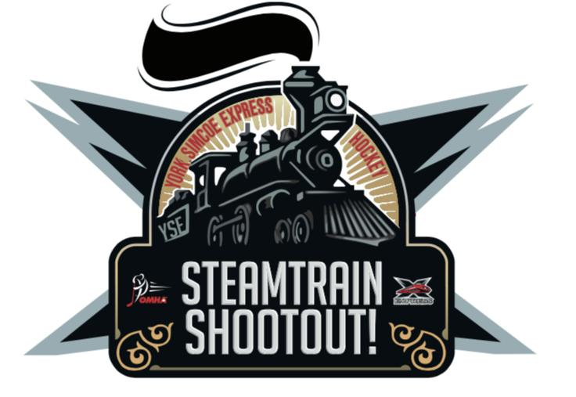

Location: Ray Twinny Rec Complex, Newmarket, ON

100 Eagle St. W., L3Y 1J4

Date: Friday September 19th - Sunday September 21st, 2025

**Tournament Format**

1. 8 teams participating per age group Division,
2. 2 pools of 4 for each Division; 4 Canadian and 4 American at U13 and 4 East and 4 West at U12.
3. Each team will play all 4 teams from the opposing pool once during the Regulation Round where points are accumulated per game.
4. 2 points for a win. 1 point for a tie. 0 points for a loss
5. Teams will then be ranked within their Pool from 1st - 4th using most points to least.
6. All teams will then play one final (5th) game on Sunday against the team from the opposite Pool that finished the Regulation Round with the same rank (1v1, 2v2, etc.)
7. All teams will play 5 games total.
8. The 1st place v 1st place game will serve as the Championship game.
9. Each team will play all teams from the opposing Pool and will play no games against teams from within their own Pool.

**Tie-Breaker involving 2 or 3 teams**

1. In the event of a tie in points between teams after the Regulation Round, the following procedure will be used to determine the higher seed:

(a) The team with the greater Goal Differential (+/-) will gain the higher position

(b) The team with the most wins   
(c) Lowest goals against  
(d) Most goals for

(e) Least penalty minutes

(f) Quickest goal scored in the first game played in the tournament

**Overtime**

1. There will be no overtime in the Regulation Round
2. Overtime will only be played in the 1v1 games on Sunday and will consist of:

* 5 minutes of 3v3
* Followed by a shootout of 3 shooters and then sudden death shootout until a winner is determined. Home team shoots first in shootout.

**Game Play Rules**

1. Each U13 game will consist of 3 periods of 15 minutes stop time each. There will be a flood between the second and third period of each game.
2. Each U12 game will be 10/15/15 period lengths stop time with no flood between periods.
3. 3-person referee system at U13, 2-person system at U12
4. Please be prepared to start each game up to 15 minutes early if the ice is ready
5. On ice warm-up will be 3 min for all games
6. No timeouts during Regulation Round. One 30-second timeout allowed per team only in the Sunday 1v1 games (to be used at any time including OT)
7. Mercy Rule - run time in the third period only if there is a goal differential of 5 goals or greater
8. Teams will wear Steam Train Shootout jerseys and socks for all games.

**Additional Rules**

1. All decisions made by the Tournament Staff and on-ice officials are final. There are no disputes, protests or appeals.
2. The rules of Hockey Canada and the OMHA will apply to all games with the exception of the additions specified in this document.
3. No body-checking allowed.
4. Teams may use affiliated players, provided that they are listed on the approved roster. AP players cannot be added after the tournament starts.
5. Any team who is found to have played using an ineligible player will forfeit the game in question. For the purpose of tie breakers, a game forfeited will be scored 3-0 in favor of the non-penalized team.
6. No abusive behavior by coaches, players or fans will be tolerated. An Offender will be removed from the game or tournament, as assessed by the applicable officials.
7. Protective Equipment. Teams are permitted to wear whatever equipment their League mandates and not required to meet the OMHA standards.
8. All players must wear a neck guard for this tournament.
9. All Sunday games will have a Player of the Game award

**Ontario Rule Clarifications**

* Minor penalties are 2 minutes in length
* There will be no icing called against the shorthanded team during a penalty kill
* Delayed offside will be played and not whistled down